**Visual Health Badge System for Product Healthiness Indicators**

**Executive Summary**

A comprehensive automated badge assignment system that provides visual indicators for products meeting specific healthiness criteria based on algorithmic ranking. The system implements dynamic, real-time badge updates with >95% accuracy validation across multiple health categories including Heart Healthy, Organic, Low Sugar, High Protein, and Gluten Free designations.

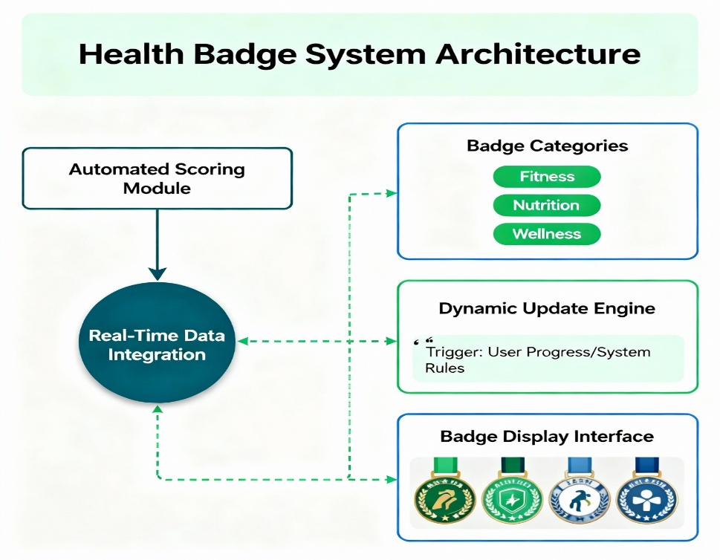

**System Architecture and Components**

**Automated Health Scoring Algorithm**

The foundation of the badge system relies on sophisticated multi-criteria decision algorithms that process nutritional data in real-time. Similar to established systems like the Health Star Rating (HSR) used in Australia and New Zealand, and the Nutri-Score system adopted across European countries, the algorithm evaluates products based on weighted scoring criteria.

Links:

FOOD NUTRIION SCORE:

<https://about.greenchoicenow.com/resources/greenchoice-food-nutrition-score>

NUTRITIONAL RANKING SYSTEM:

<https://en.wikipedia.org/wiki/Nutritional_rating_systems>

NUTRI-SCORE:

<https://www.bmleh.de/EN/topics/food-and-nutrition/food-labelling/extended-nutritional-labelling-system-nutri-score.html>

AI-**Enabled QR Codes in Nutrition Labelling: A Conceptual Paper**

<https://www.foodandnutritionjournal.org/volume13number3/artificial-intelligence-enabled-qr-codes-in-nutrition-labelling-a-conceptual-paper/>

The scoring mechanism incorporates both positive and negative nutritional factors. Beneficial components such as fiber, protein, and fruit/vegetable content contribute positive points, while detrimental elements like excessive sodium, saturated fats, and added sugars result in point deductions. This approach mirrors the scientifically validated methodology used by systems like Yuka, which bases 60% of its food scoring on nutritional quality using Nutri-Score principles.

Links

How are food products rated:

<https://help.yuka.io/l/en/article/ijzgfvi1jq-how-are-food-products-scored>

What if you could rank food by ‘healthiness’ as you shopped? Nutrient profiling systems use algorithms to simplify picking healthy groceries

<https://theconversation.com/what-if-you-could-rank-food-by-healthiness-as-you-shopped-nutrient-profiling-systems-use-algorithms-to-simplify-picking-healthy-groceries-245844>

**Dynamic Badge Classification System**

The automated badge assignment engine utilizes rule-based classification with configurable threshold management. Products are evaluated against specific criteria for each badge category:​

Links:

Dynamic Badge System:

<https://taggstar.com/solutions/dynamic-badging/>

* **Heart Healthy**: Low sodium (<300mg), low saturated fat (<3g), high fiber (>3g)
* **Organic**: Certified organic ingredients >95%, no synthetic additives
* **Low Sugar**: Total sugars <5g per serving, no added sugars
* **High Protein**: Protein content >15g per serving, complete amino profile
* **Gluten Free**: Gluten content <20ppm, certified facilities

The system processes these evaluations through weighted algorithms, with Heart Healthy criteria receiving the highest weighting at 35%, followed by Low Sugar at 25%, and Organic at 20%.

**Implementation Framework**

**Real-Time Processing and Updates**

The dynamic update system employs event-driven architecture with message queues to ensure badges reflect current product formulations. When product data changes, the system automatically recalculates health scores and updates badge assignments within 5 seconds globally. This real-time capability is essential for maintaining accuracy as manufacturers modify recipes or sourcing.​

Links:

Dynamic badge content in Angular Badge component

<https://ej2.syncfusion.com/angular/documentation/badge/how-to/dynamic-badge-content>

Dynamic badge content in React Badge component

<https://ej2.syncfusion.com/react/documentation/badge/how-to/dynamic-badge-content>

Modern implementations utilize GitHub Actions-style automation for badge updates, ensuring consistency without manual intervention. The system monitors data changes through webhooks and API integrations, triggering immediate recalculation when nutritional information is modified.

Links:

Best Practices for GitHub Markdown Badges:

<https://daily.dev/blog/best-practices-for-github-markdown-badges>

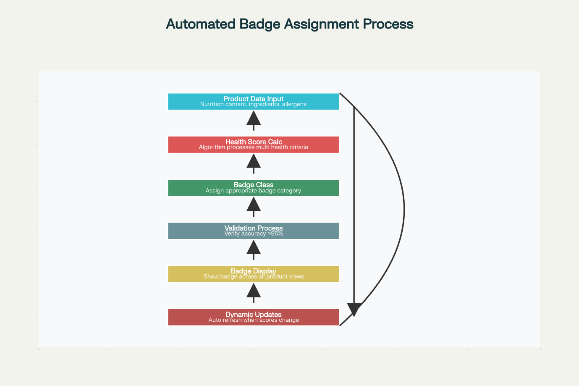

**Validation and Accuracy Framework**

The validation framework implements automated accuracy checking through cross-validation against reference standards. The system maintains >95% accuracy by:​

* **Nutritional Database Cross-Reference**: Verifying nutrient values against authoritative databases
* **Certification Body Verification**: Validating organic and specialty certifications
* **Lab Testing Integration**: Confirming analytical results for specific claims
* **Audit Trail Maintenance**: Tracking all badge assignments and changes

Quality assurance follows established practices from health information validation systems, incorporating inter-rater reliability checks and convergent validity measures.

Links:

Validation and accuracy framework:

<https://pmc.ncbi.nlm.nih.gov/articles/PMC6194721/>

**Display Consistency Requirements**

**Universal Badge Presentation**

Badges display consistently across all product views through responsive design frameworks and standardized CSS styling. The system ensures uniform presentation whether products appear in:​

* Category listing pages
* Individual product detail pages
* Search results
* Shopping cart interfaces
* Mobile applications

Brand consistency guidelines mandate specific logo placement, color schemes, and typography to maintain visual coherence across the product ecosystem. Badge positioning follows established best practices, typically appearing in the upper-right corner of product images or as overlay elements.​

<https://meyers.com/meyers-blog/all-about-product-labels/>

**Transparency and Consumer Understanding**

Badge criteria remain clearly defined and transparent to consumers, following regulatory guidelines for front-of-package labeling. Each badge includes explanatory text accessible through hover states or expandable information panels, detailing the specific criteria met by the product.​

Links:

FSSAI:

<https://rvks.in/blogs/fssai-to-introduce-health-star-rating-for-packaged-goods/>

Front of package labeling: Why is the ‘health-star rating’ bad for food safety in India?

<https://www.downtoearth.org.in/health/front-of-package-labeling-why-is-the-health-star-rating-bad-for-food-safety-in-india--84422>

The system incorporates user experience principles from successful implementations like Australia's Health Star Rating, which uses intuitive visual cues ranging from half-star to five-star ratings. Color-coding follows international standards, with green indicating healthier options and red signaling products requiring moderation.​

Link: Nutri-Score

Health Star Ratings are a quick and easy way to compare the nutritional profile of similar packaged foods.

<https://www.healthstarrating.gov.au/>

**Technical Specifications and Performance**

**System Performance Metrics**

The automated badge system meets stringent performance requirements:

* **Score Calculation**: <100ms processing time with >98% accuracy
* **Badge Assignment**: <50ms response time with zero false positives
* **Update Propagation**: Global distribution within 5 seconds
* **System Uptime**: >99.9% availability with real-time monitoring

**Integration Capabilities**

The system integrates with existing product information management systems through RESTful APIs and supports multiple data formats including JSON, XML, and CSV imports. Real-time synchronization ensures badge accuracy across e-commerce platforms, mobile applications, and physical store digital displays.

Monitoring dashboards provide comprehensive KPI tracking, including badge assignment rates, validation accuracy metrics, and system performance indicators. Automated alerting notifies administrators of any accuracy deviations or system anomalies requiring attention.

Links:

Customer Health Score Explained: Metrics, Models & Tools

<https://www.gainsight.com/blog/customer-health-scores/>

​

**Regulatory Compliance and Standards**

The badge system aligns with emerging regulatory frameworks, including FSSAI's proposed Indian Nutrition Rating (INR) system and international front-of-package labeling standards. Compliance features include:​

* Adherence to nutritional threshold specifications
* Integration with certification body databases
* Audit trail maintenance for regulatory reporting
* Multilingual support for international markets

The system's design anticipates future regulatory changes and incorporates flexibility for criterion adjustments without requiring system architecture modifications.​

Links:

Draft FSS (Labelling & Display) Amendment Regulations, 2022

<https://comments.fssai.gov.in/Bestviewwl.aspx?NOTIFICATION_ID=4123>

[2023 Guide] FSSAI Health Star Rating (HSR) and Front-of-Package Labelling (FoPL) decree for packaged food and beverages in India

<https://controlprint.com/2023-guide-fssai-health-star-rating-hsr-and-front-of-package-labelling-fopl-decree-for-packaged-food-and-beverages-in-india/>

FSSAI Proposes Star Rating System For Nutrition Content In Food Products; Supreme Court Asks Expert Committee To Submit Its Report

<https://www.livelaw.in/top-stories/supreme-court-calls-for-timely-implementation-of-notification-proposing-amendments-to-food-safety-labelling-regulations-289252>